Carer administration of rectal suppositories
If a person is unable to swallow and they have a high temperature or pain, this can be treated by giving diclofenac rectally (into the bottom)
Please follow these instructions. If you need guidance or advice please call the St Margaret’s hospice advice line on 0845 0708910

- Wash your hands thoroughly and put on gloves. | 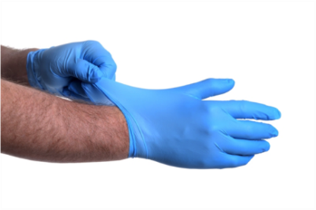
- Have the medication ready. Remove the suppository from the packet. Have the lubricant at hand. | 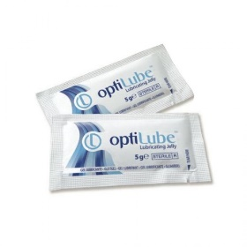
- Position the individual on their side. You may require help from a friend or relative to do this safely.  - Remove or pull their underwear down and out of the way.  - Gently pull the uppermost knee towards their chest as far as is comfortable. | 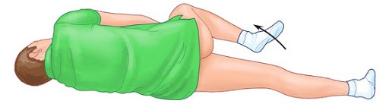
- Lift the upper buttock to expose the rectal area.

- Apply a small amount of lubricant to the tablets and to the tip of the gloved finger you will use to insert it with.  - Insert the tablets through the anus. Gently push them inside to approx. 1 inch.  - Keep the individual on their side for 5 minutes if comfortable to prevent medication from being expelled. After this gently reposition them back to a comfortable position. | 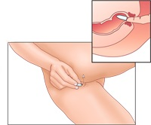
- Remove your gloves and wash your hands.

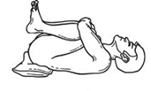
NB. If positioning the individual on their side is difficult consider keeping them on their back but lifting their legs up. Again, help from a friend or relative to do this may be needed.

