Carer administration of scopoderm patch

This medication is used to control nausea and to reduce noisy breathing.
Remove the patch from the packing and apply to the area below the ear, behind the angle of the jaw
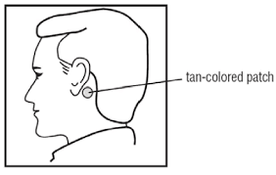
This is changed every 3 days to the alternate side

