Carer administration of sublingual lorazepam

This medication can be given to reduce the symptoms of anxiety, breathlessness and agitation. If you have used the Somerset Symptom control assessment chart, and medication is required, follow these instruction to administer it.
If you are unsure then please call St Margaret’s hospice for guidance 0845 0708910

- Wash your hands and put on gloves. | 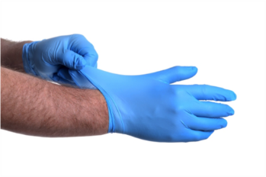
- Remove the tablet of lorazepam from its wrapper and place it in the palm of your hand. | 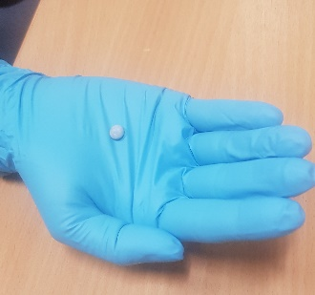
- Add a few drops of water to the tablet in your hand. You will see the tablet start to dissolve.

- Support the head. Gently place the dissolving tablet under the patients tongue.  - If their mouth is particularly dry consider adding a couple more drops of water to the tablet inside the mouth. | 